CS 255 System Design Document Template

UML Diagrams

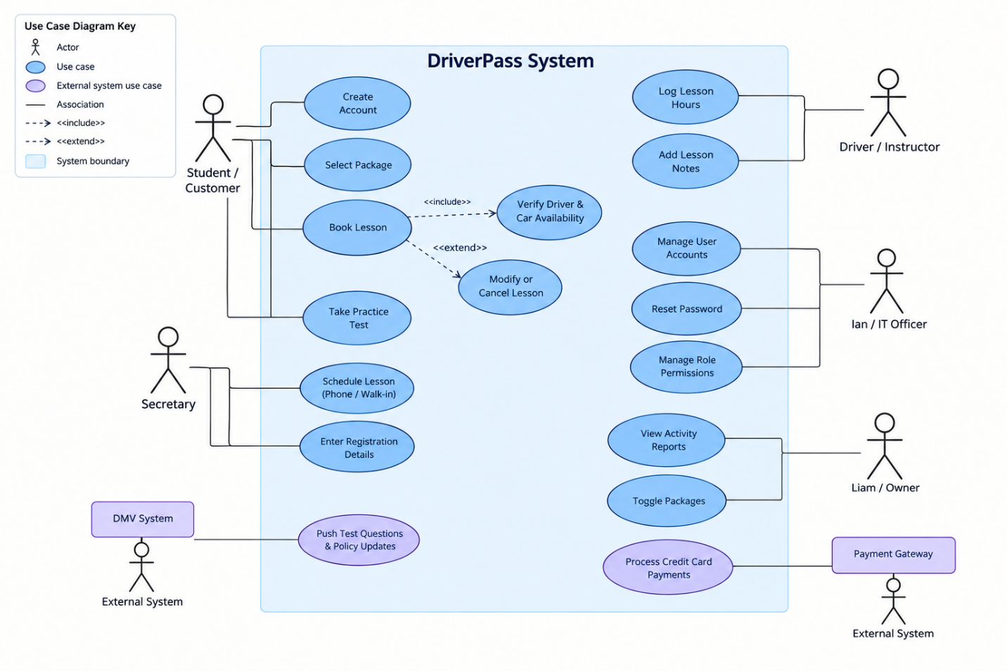
UML Use Case Diagram

UML Activity Diagrams
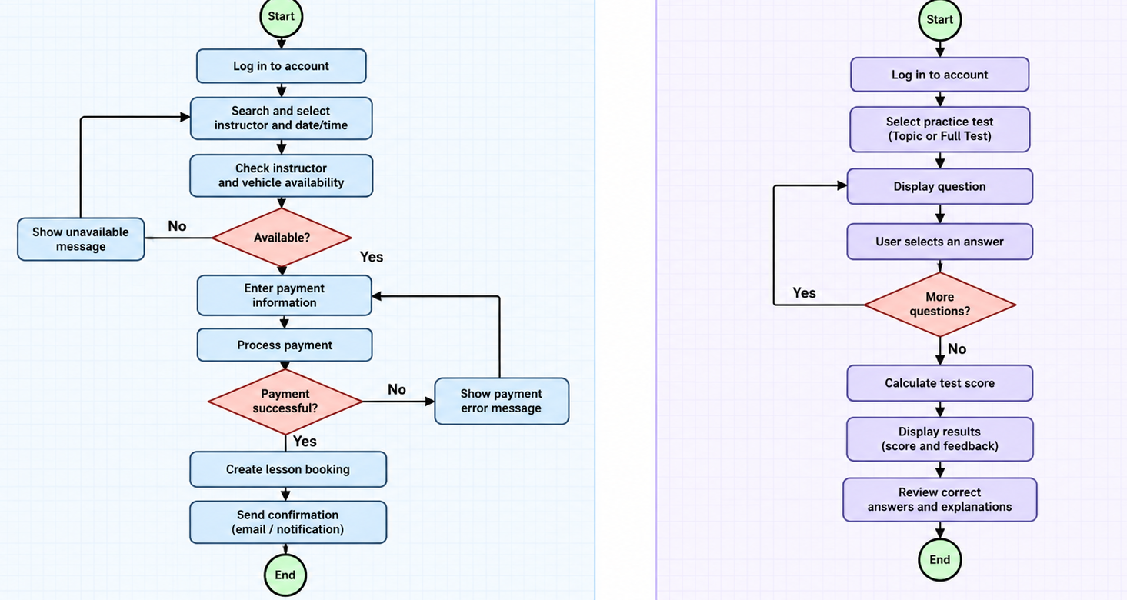

UML Sequence Diagram

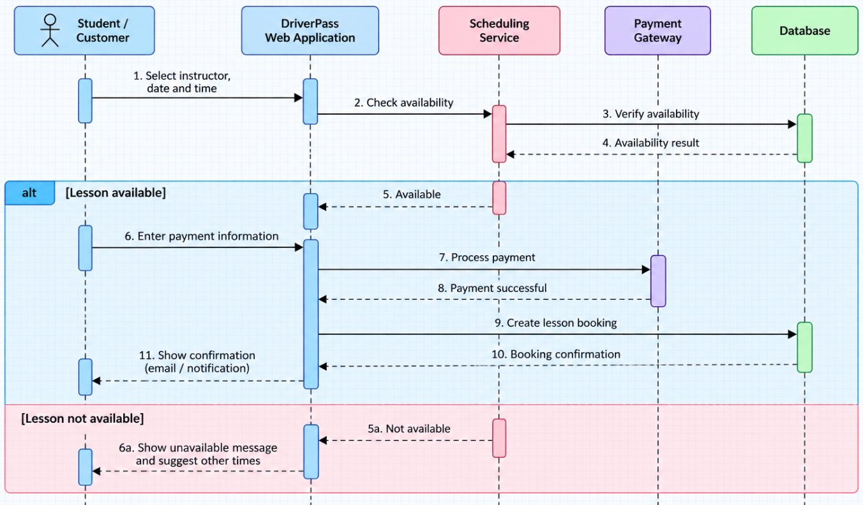

UML Class Diagram

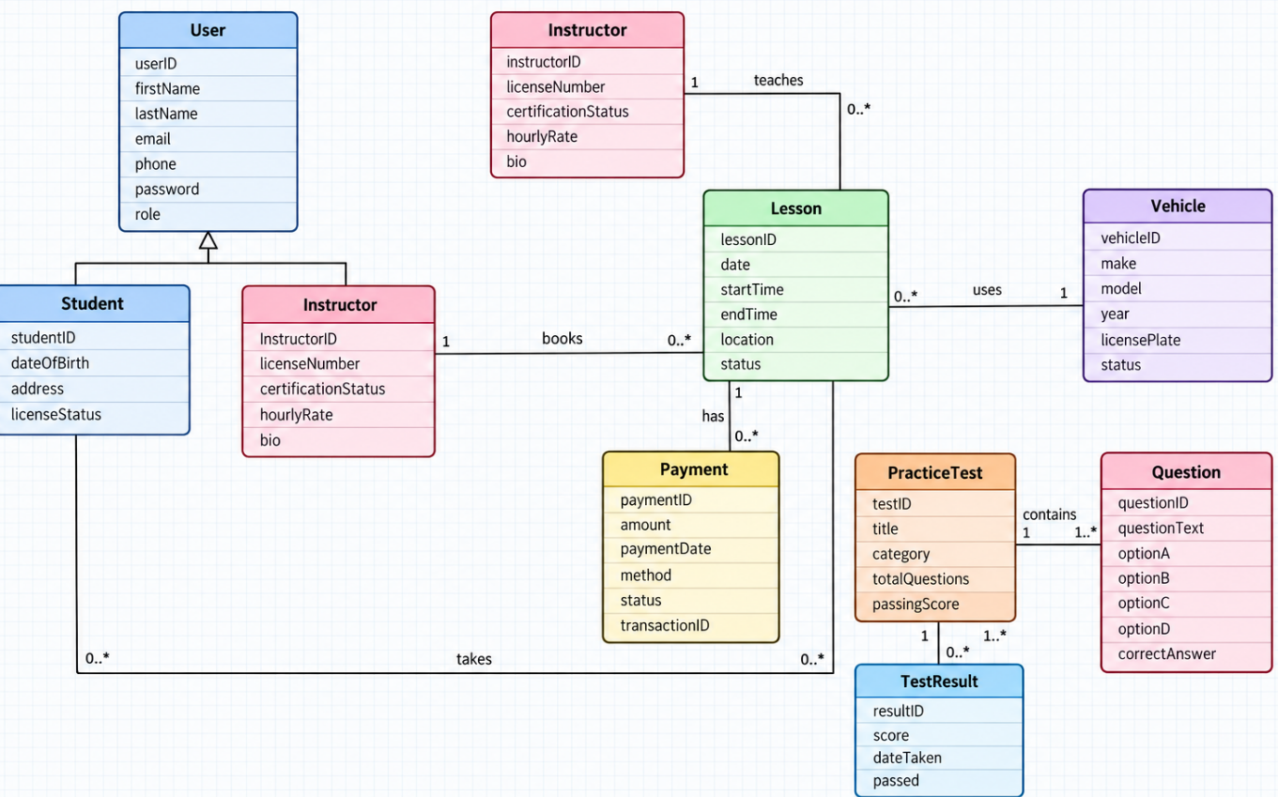

Technical Requirements
The DriverPass system will need the right hardware, software, and internet services to work properly. The main goal is to create a system that is easy to use, safe, and available for students, instructors, and staff.
Hardware Requirements
DriverPass will need computers for employees to manage student information, schedules, payments, and reports. Instructors should be able to use their phones, tablets, or computers to check their schedules and update lesson information. Students will also need a device with internet access to book lessons and take practice tests. The company will need a server to store information and keep the system running.
Software Requirements
The system should work on common web browsers like Google Chrome, Safari, and Microsoft Edge. DriverPass will also need a database, such as MySQL, to store student accounts, lesson schedules, payments, and test results. Users should be able to log in to their accounts, and each type of user should have access to different features depending on their role. The system will also need an online payment service so students can pay for their lessons.
Development Tools
Network and Infrastructure Requirements
DriverPass will need a stable internet connection so users can access the system at any time. The company can use a cloud service, such as Amazon Web Services (AWS), to keep the website running and store its information. The system should also be able to support several users at once without becoming too slow. Regular backups will help protect important information in case something goes wrong.
Security and Maintenance Requirements
Since DriverPass will store personal information and payment records, keeping that information safe is important. Users should have secure passwords, and only authorized employees should be able to access certain information. Online payments should be handled through a trusted payment service. The system should also receive regular updates to fix problems, improve security, and make sure everything continues working correctly.
Overall, these requirements will help DriverPass create a system that allows students to book driving lessons, make payments, and take practice tests online. It will also make it easier for instructors and employees to manage schedules, track student progress, and keep information organized.

